1.Addition:-  
#include<iostream>  
using namespace std;  
int main()  
{  
float x=3.14,y=4;  
cout<<x+y;  
}

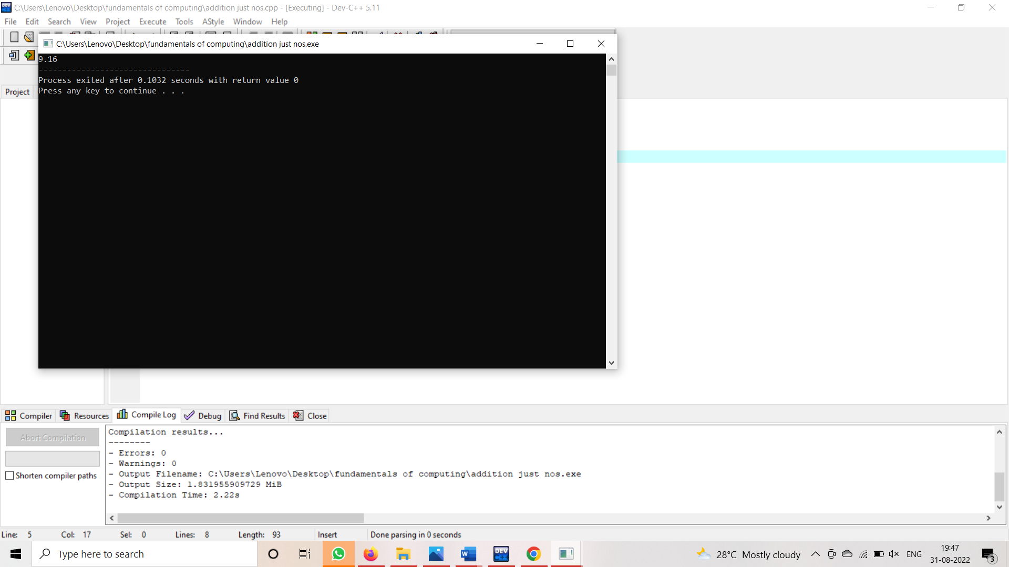

2.addition by user:-

#include<iostream>  
using namespace std;  
int main()  
{  
int x,y;  
cout<<"enter x and y";

cin>>x>>y;  
cout<<"sum is "<<x+y;  
}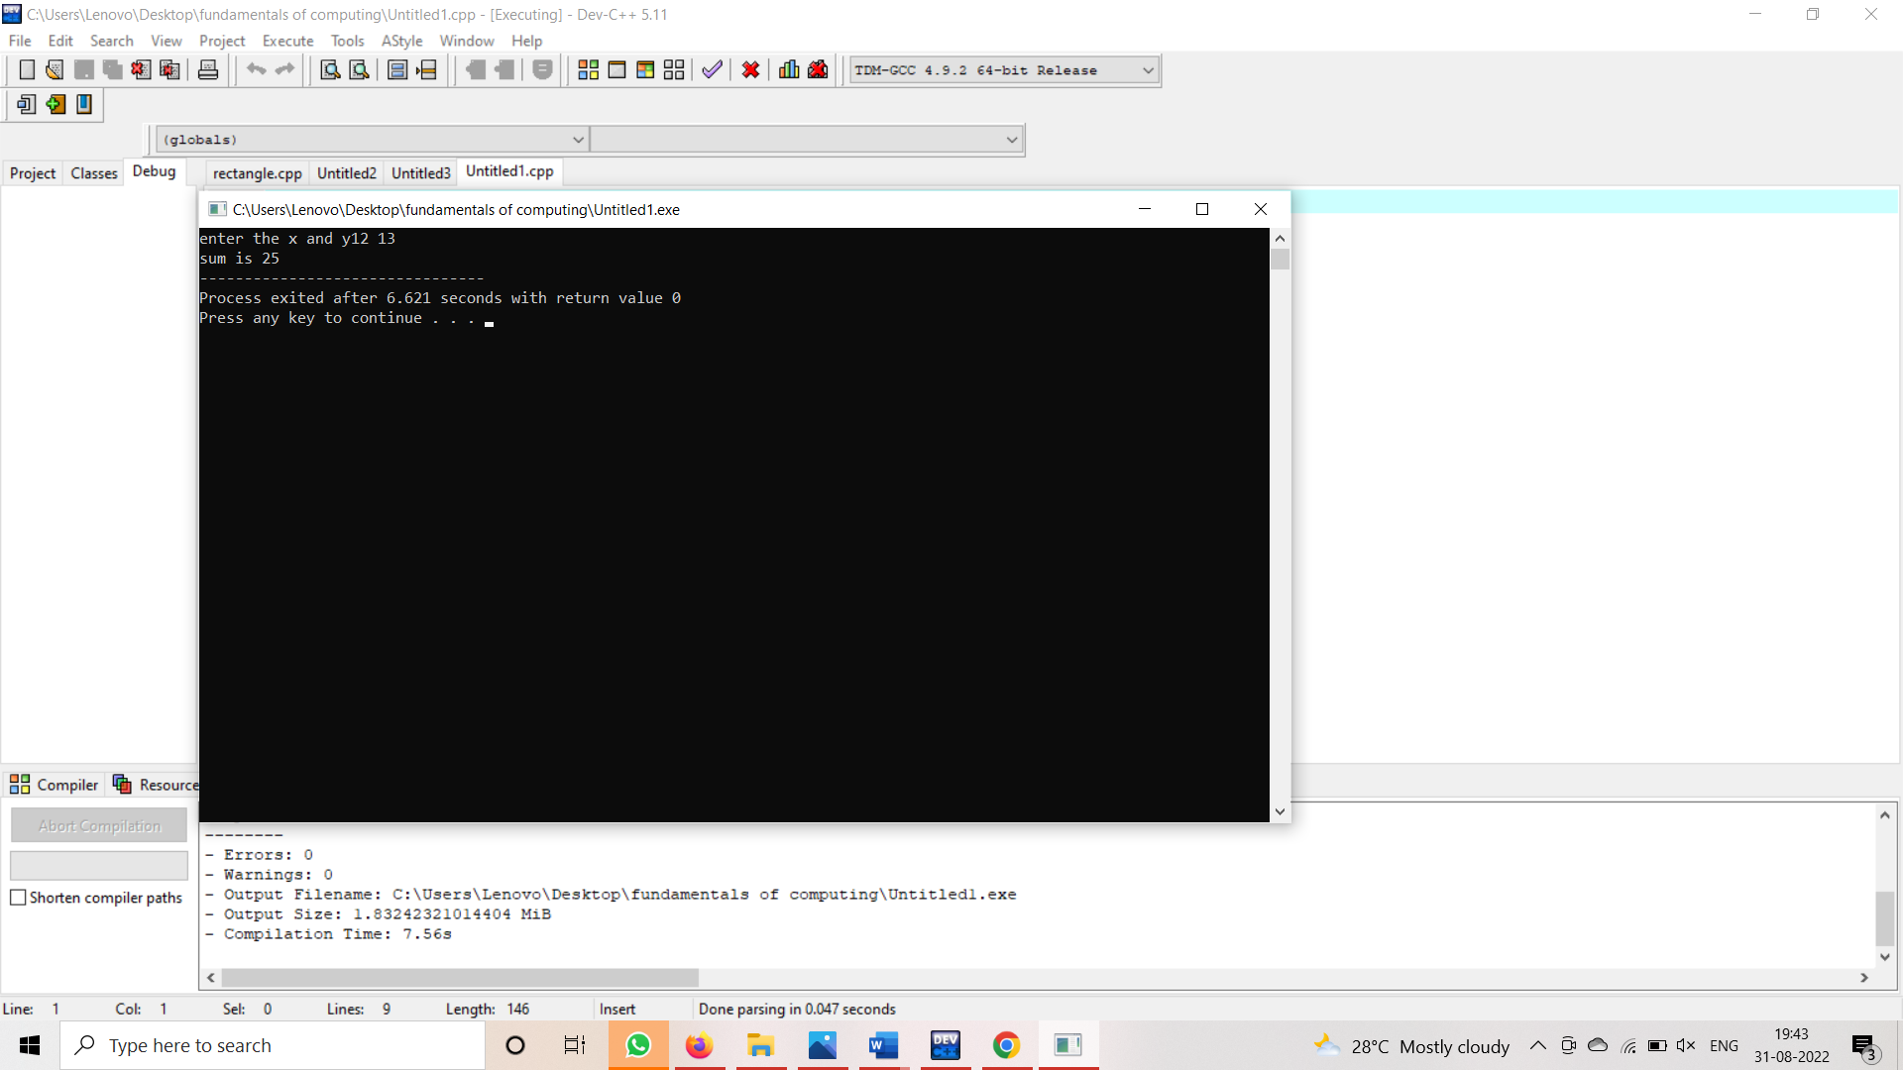  
  
3.vote eligibility:-  
#include<iostream>  
using namespace std;  
int main()  
{  
int age;  
cout<<"enter the age ";  
cin>>age;  
if(age>0&&int(age))  
{  
if(age>=18)

{  
cout<<"eligible for vote";  
}  
else  
{  
cout<<"not eligible for vote";  
}  
}  
else  
{  
cout<<"not accepted";  
}  
return 0;  
}

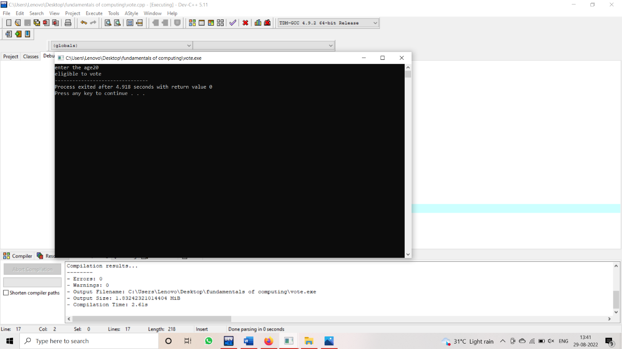

4.even or odd:-

#include<iostream>  
using namespace std;  
int main()  
{  
int num;  
cout<<"enter the number ";  
cin>>num;  
if(int(num))  
{  
if(num%2==0)  
{  
cout<<"it is even";  
}  
else  
{  
cout<<"it is odd";  
}  
}  
else  
{  
cout<<"it is not accepted";  
}  
return 0;

}